Supplementary Figure S1
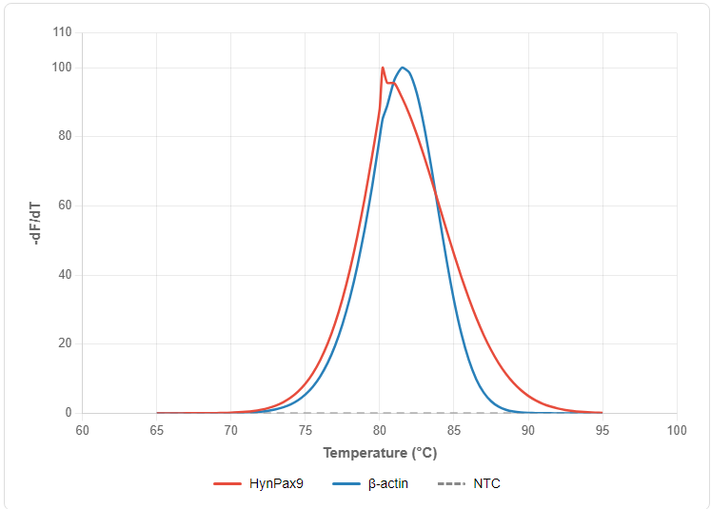
Supplementary Figure S1. Melt-curve analysis of qPCR products. Dissociation curves were generated for HynPax9 (red line) and β-actin (blue line) using representative cDNA samples, with a no-template control (NTC, gray dashed line) included. Single sharp peaks were observed at 80.2°C for HynPax9 and 81.5°C for β-actin, with no detectable signal in the NTC, confirming single-product specificity and the absence of primer-dimers.

