Supplemental Material
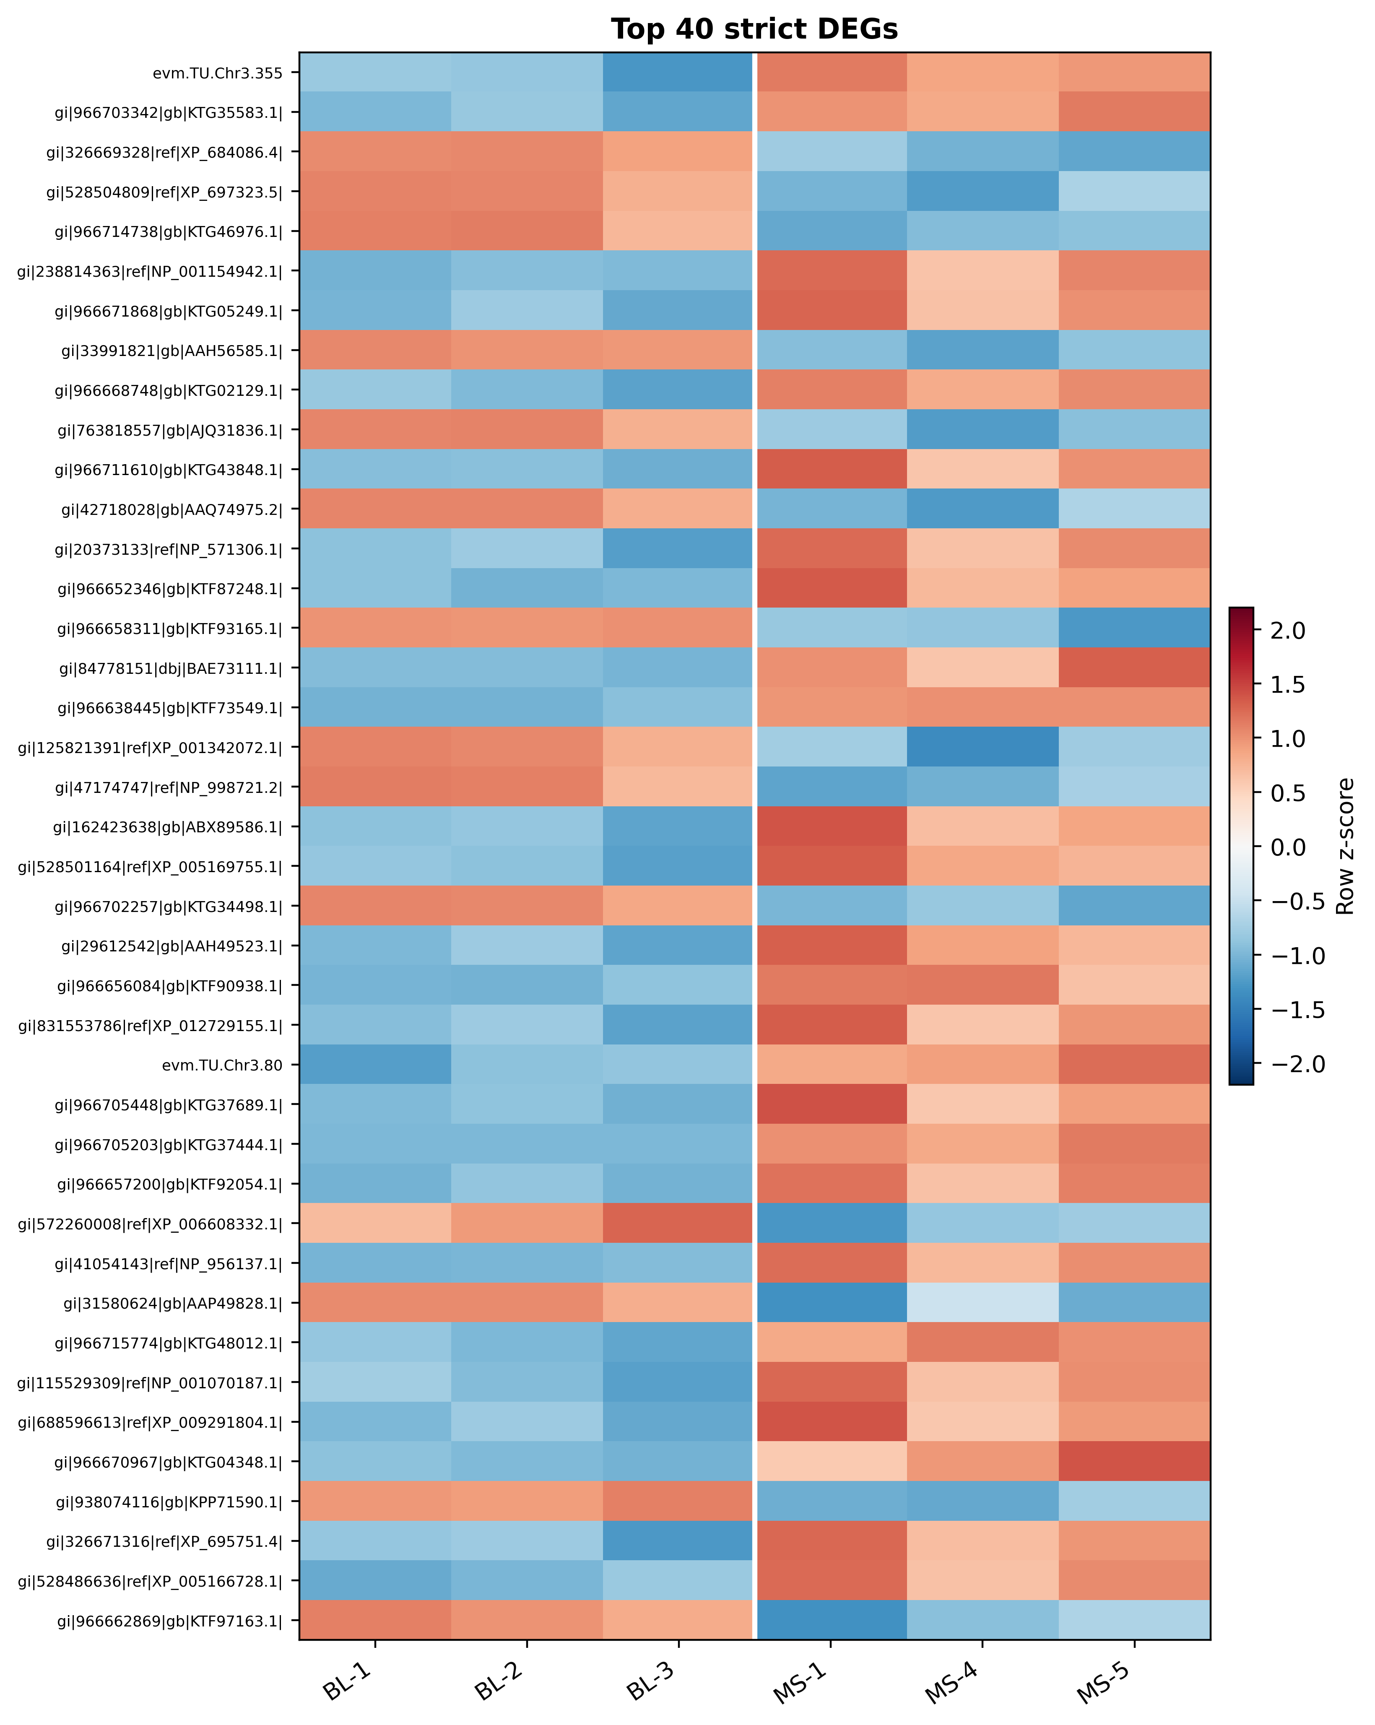
Supplemental Fig. S1 Heat map of the 40 most statistically significant strict differentially expressed transcripts. Values are row-wise z scores of log₂-transformed expression
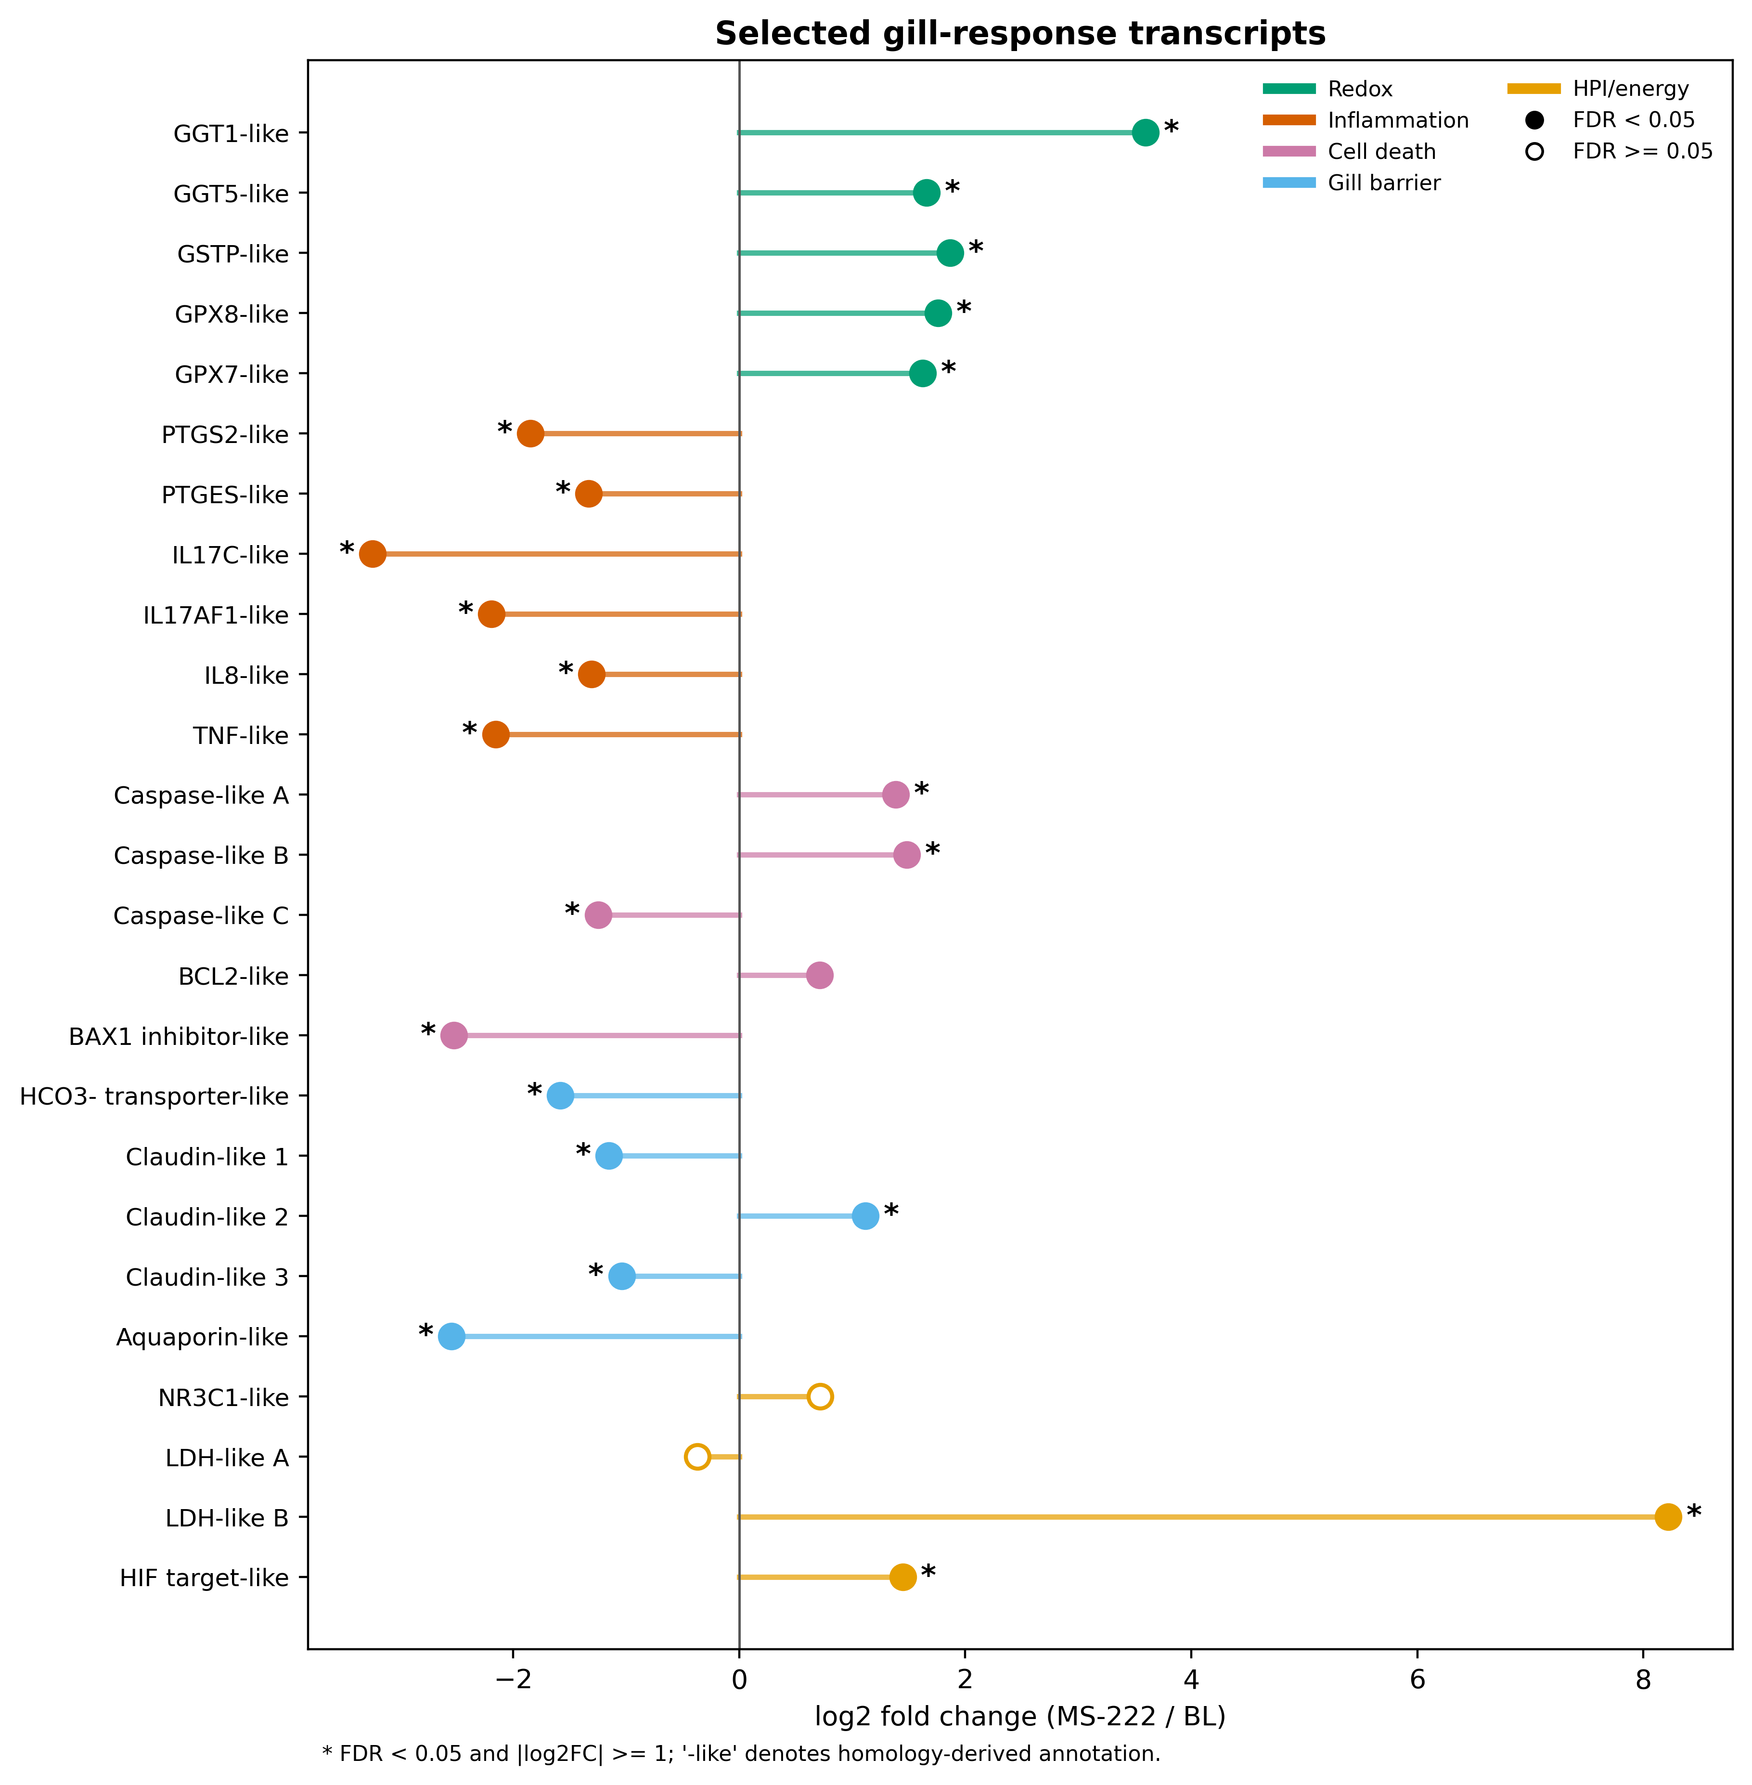
Supplemental Fig. S2 Selected transcripts spanning redox defense, inflammation, regulated cell death, gill barrier and ion regulation, and HPI-axis and energy metabolism. Filled points indicate FDR < 0.05; asterisks also indicate |log₂FC| ≥ 1
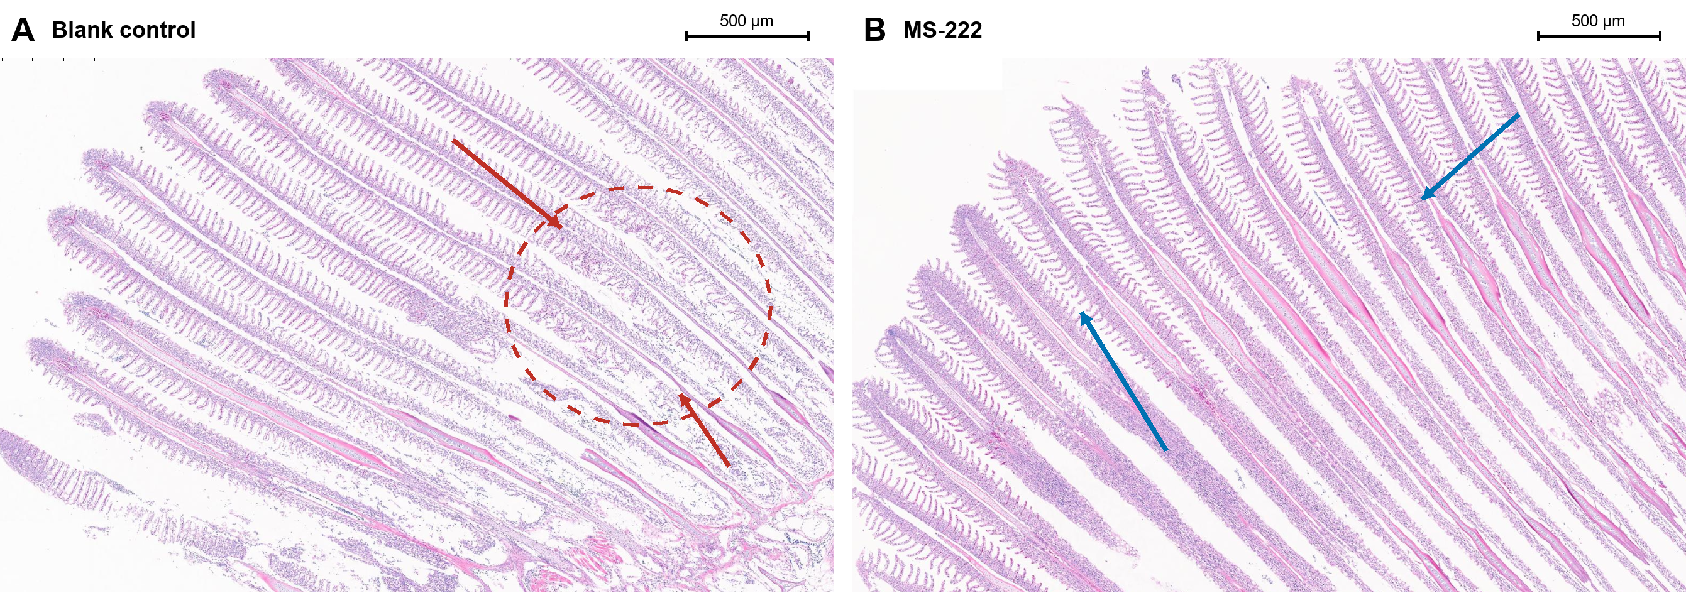
Supplemental Fig. S3 Representative low-power H&E-stained gill sections following simulated transport in juvenile Xenocypris davidi. (A) Transported blank control without anesthetic; (B) fish transported with 34 mg L⁻¹ MS-222 at the selected A2 concentration. The red dashed outline and arrows identify a representative focus of irregular, folded and partly apposed secondary-lamellar profiles in the blank-control field. Blue arrows indicate regions with comparatively regular and clearly separated secondary lamellae in the MS-222 field. No quantitative histopathological comparison was performed. Scale bars = 500 μm. Images were cropped and assembled without stain adjustment, retouching, denoising or alteration of tissue morphology.

Supplemental Table S1 Selected transcript-level responses supporting the integrated result
Functional module | Homology-derived annotation | log₂FC | FDR
Redox | GGT1-like | 3.595 | 1.40 × 10⁻⁵
Redox | GGT5-like | 1.658 | 6.36 × 10⁻¹⁴
Redox | GSTP-like | 1.867 | 5.72 × 10⁻⁸
Redox | GPX8-like | 1.761 | 0.00487
Inflammation | PTGS2-like | −1.848 | 1.93 × 10⁻⁸
Inflammation | IL17C-like | −3.242 | 4.47 × 10⁻⁶
Inflammation | IL8-like | −1.304 | 5.45 × 10⁻⁵
Inflammation | TNF-like | −2.155 | 7.80 × 10⁻⁸
Cell death | Caspase-like A | 1.384 | 1.10 × 10⁻⁴
Cell death | Caspase-like C | −1.248 | 0.00111
Gill barrier | SLC4/HCO₃⁻ transporter-like | −1.584 | 1.84 × 10⁻²¹
Gill barrier | Aquaporin-like | −2.545 | 0.00104
Annotation note: The suffix “-like” should be retained until orthology and standardized gene symbols have been independently verified.

